# Overview of the analysis

As many employees at Pewlett-Hackard are about to reach retirement age, the purpose of this analysis is to determine the number of retiring employees per title and identify employees who are eligible to participate in a mentorship program.

# Results

Below are four major points resulted from the two analyses conducted:

1. There are 133,776 employees in the retirement_titles table. Several of these employees held multiple titles throughout the years. Counting the distinct employees only, that number is reduced to 90,398 employees
2. Using Excel’s pivot tables and some data manipulation, we find that 43% of eligible of retirement employees have worked in PH between 24 and 32 years and only 4% have worked for 8 to 16 years

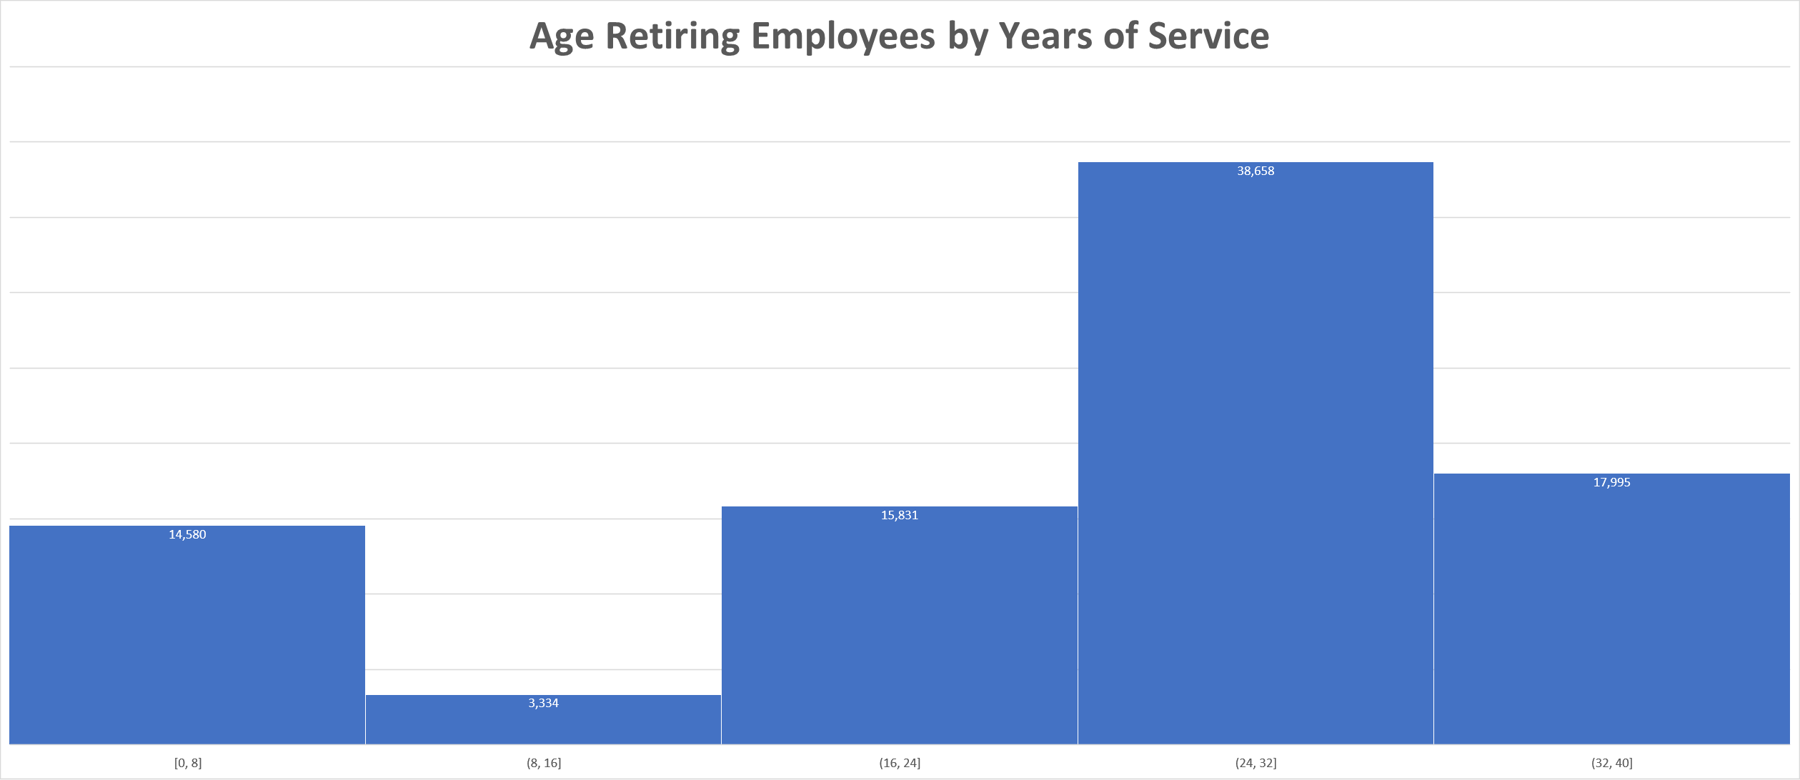

1. Based on the retiring_titles table, we can see that most titles are Senior Engineers and least are managers

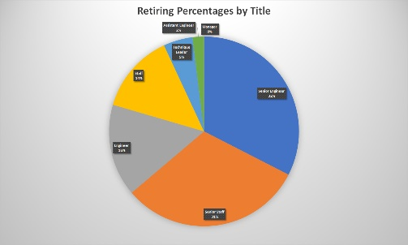

1. Analyzing the mentorship_eligibilty table and using today’s date, April 10th, 2021, we can conclude that the average (mean) years of service for mentors is: 28 years

# Summary

Provide high-level responses to the following questions, then provide two additional queries or tables that may provide more insight into the upcoming "silver tsunami."

* + How many roles will need to be filled as the "silver tsunami" begins to make an impact?
    - By looking at the retiring_titles table, we can confirm that the number is 90,398 employees which is the same number as roles need to be filled
  + Are there enough qualified, retirement-ready employees in the departments to mentor the next generation of Pewlett Hackard employees?

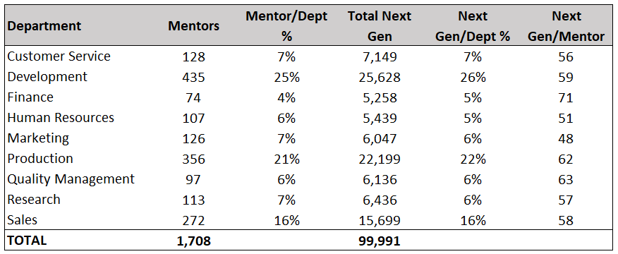

**Query 1**

-- Total eligible for retirement employees per department

SELECT

dp.dept_name AS "Department",

COUNT(emp.emp_no) AS "Total Employees"

FROM Employees AS emp

INNER JOIN dept_emp AS de

ON emp.emp_no = de.emp_no

INNER JOIN Departments AS dp

ON de.dept_no = dp.dept_no

WHERE (emp.birth_date BETWEEN '1952-01-01' AND '1955-12-31')

GROUP BY dp.dept_name

ORDER BY "Total Employees" DESC;

**Query 2**

-- Total mentors per department

SELECT

dt.dept_name AS "Department",

COUNT(me.emp_no) AS "Total Mentors"

FROM mentorship_eligibilty AS me

INNER JOIN dept_emp AS de

ON me.emp_no = de.emp_no

INNER JOIN Departments AS dt

ON de.dept_no = dt.dept_no

GROUP BY dt.dept_name

ORDER BY "Total Mentors" DESC;